

Employment at MACC
APPLICANTS INFORMATION PACK

July 13, 2017

Appointment of Staff
Mount Annan Christian College (MACC) exists to provide a Christ-centred learning environment that empowers each individual to enjoy a life of purpose. This is facilitated through a culture which is highly regarded for being a nurturing, caring and supportive community which provides a strong sense of belonging for each individual. Central to the community at MACC are the students, staff and parent body – with each playing a vital role in contributing to the overall environment and MACC experience. Some of the MACC distinctives include:

- Innovative and creative learning environment
- Passion and curiosity for lifelong learning
- Unified community showing Integrity, fairness and compassion – being true to Christ, ourselves and one another
- Working together through diligence and discipline to respect one another
- A commitment to Missions and service and making a positive difference to those around us
- Strong community culture of collaboration and inclusiveness
- Located in beautiful surrounds in the South West MacArthur region, boasting clean, clear air and a natural environment.

About MACC
The College was established in 1999 as a ministry of C3MA and is currently going through a new phase of growth and development.

MACC is competitively placed within the region with moderate school fees, and is an Independent College, from Prep to Year 12, Christian in ethos and delivery of education with vibrant, motivated cohesive staff.

Situated within the fastest growing region of Sydney, MACC is perfectly located for growth within the area.

The College Board has accepted the resignation of Mr Nathan Gray after a long tenure and are now working with the Community to appoint a leader to grow the College into the next phase. A new phase of continued strength within are areas of innovative learning, increase of enrolments and diversity of program offerings.



VISION
To provide a Christ-centred learning environment that empowers each individual to enjoy a life of purpose.

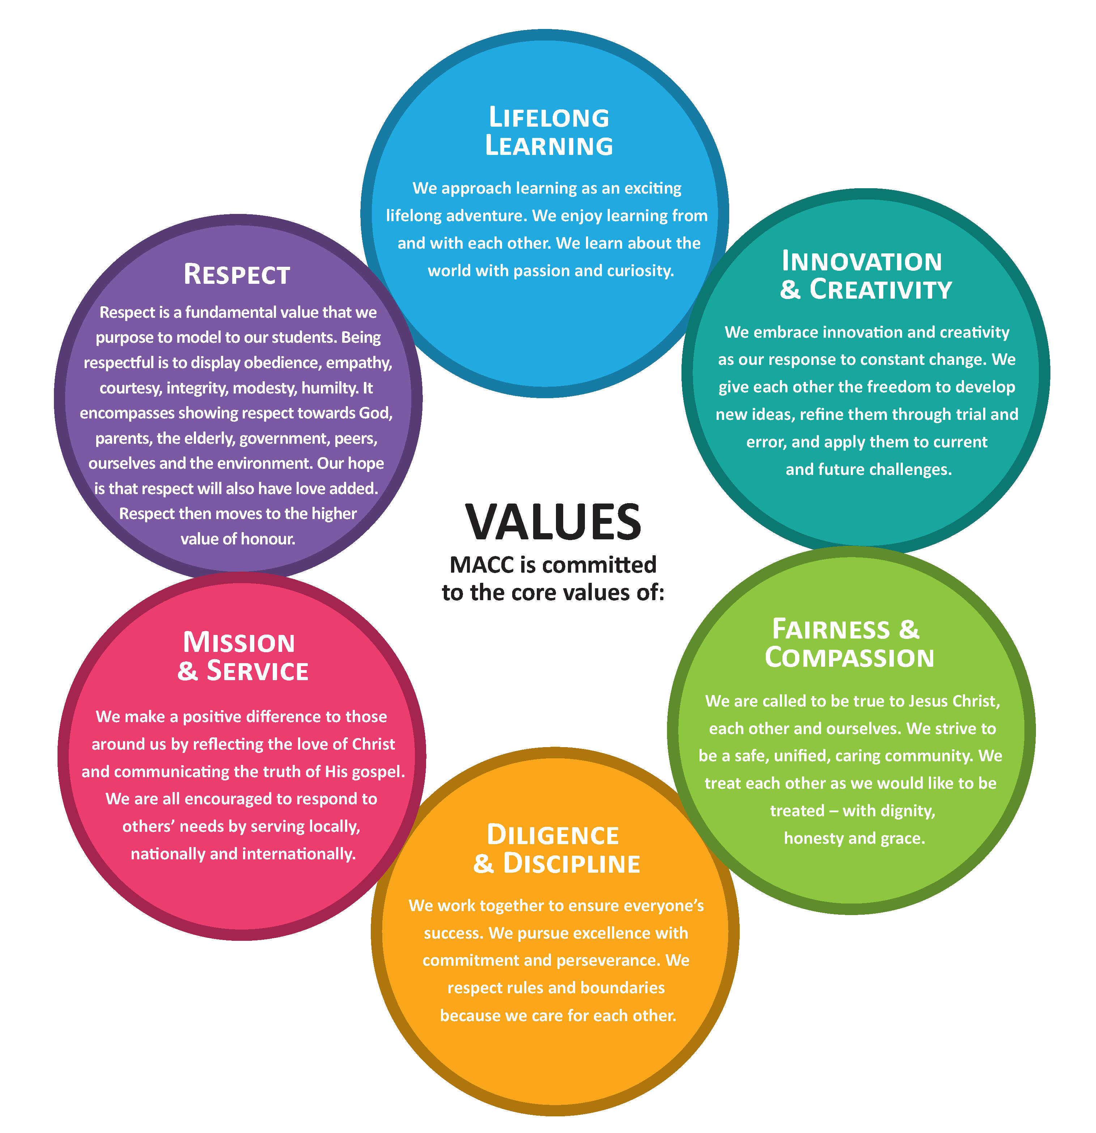

Our Staff
The staff are engaged and committed to empowering individuals, strengthening and nurturing community, equipping students and providing a holistic approach to develop each individual.

MACC believes we should all live a life of purpose and are committed to building on the strengths of each student to contribute effectively to society, creating pathways for future study and work.

The staff culture is cohesive and team focused - with many staff having supported the College with years of faithful service. There are currently 60 staff, with valued casual staff members supplementing the team when required.

Staff belong to churches with a range of Christian denominations and we provide opportunities when hiring staff to work in a Christian environment, whilst showcasing their talents and professional excellence, and attesting to our ethos and Statement of Christian faith.

Our Students
It has been noted that our students are respectful, enthusiastic and well-mannered young people with a love for learning. Our catchment is large with many students travelling on our College bus to the campus each day.

We offer sporting and academic scholarships with our students excelling in areas of academia, sport, creative and musical arts, agriculture, citizenship, and innovation within STEM_Education subjects (Science, Technology, Engineering, Mathematics).

Many students have grown up at MACC having started in Prep, moving right through to Year 12. MACC enrols families – not just students, so parents, grandparents, relatives and friends are also invested in the education of our students.



Our Families
MACC is well known for the provision of a nurturing environment and parents make their enrolment choices with that key factor in mind. Our Prep program offers families options for assistance with and before Kindergarten enrolment, whilst our Year 11 and 12 programs provide a variety of opportunities for learning inclusive of external providers such as VET and TVET.

The College operates a Before and After School Care program to help families meet their work and life commitments. The staff in these programs partner with families to ensure children have the very best of care.

Opportunities for families to be collaborative and involved in many facets of school life assist the lifelong learning principles.

Facilities
MACC is set on 37 acres in one of Sydney’s fastest growing regions and is situated opposite the beautiful Mount Annan Botanical Garden estate. The College and C3 Mount Annan Church together share the property. As a purpose built College reflective of the needs of students, staff and family, the long driveway off Narellan Road, provides security and serenity in a rural setting. The Agriculture plot is home to sheep, cattle, poultry and sustainable, organic produce. The STEM_Ed rooms are open and fluid providing a collaborative learning environment conducive to creativity and innovation.

Our Multi-Purpose Hall is sought after as a state-of-the-art basketball and sporting venue. This facility connects MACC to the community providing opportunities to partner together in projects and events.

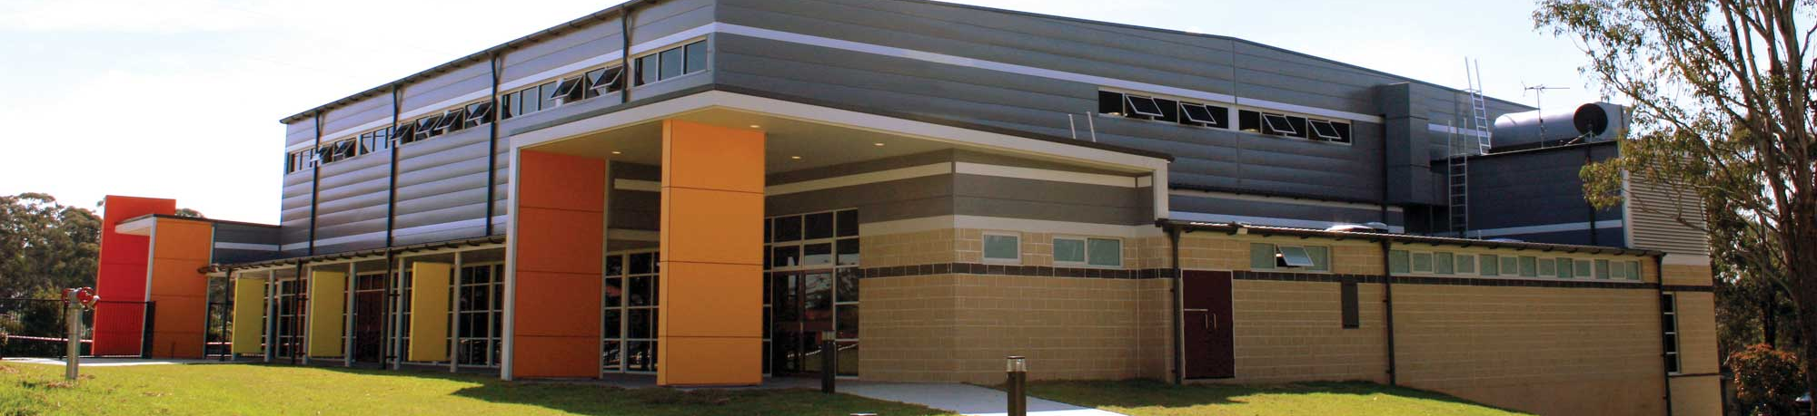

MACC’s desire to be a leader in innovation is underpinned by the recent establishment of the Mount Annan Innovation Centre (MAIC) focused on preparing

MACC’s desire to be a leader in innovation is underpinned by the recent establishment of the Mount Annan Innovation Centre (MAIC) focused on preparing both students and teachers to succeed in a changing world.

Preparing Students
We believe strongly that we are preparing today’s students for tomorrow’s world by sculpting students to succeed in tomorrow’s workforce. This is achieved by engaging with industry and tertiary providers to strengthen pathways.

We are committed to develop:

Adaptability
Agility
Innovation
Initiative
Courage
Awareness of new trends
Problem solving
Empathy
Creativity
Transferrable skills.

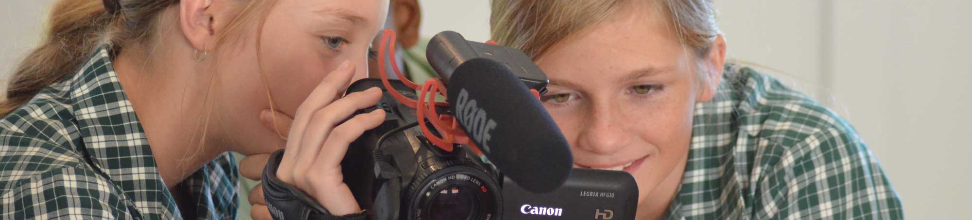

Our Strengths
MACC provides a nurturing, co-educational learning environment for students in Prep – Year 12.

MACC is known for providing a nurturing environment that is family friendly, caring and supportive. It is a Christian community with compassionate staff and a sense of community.

With a high level of professionalism and a desire to achieve the best academically, we provide an innovative and visionary environment. This is not for a generic sense of purpose but to enhance individual self-knowledge of gifts and strengths that can be utilized for lifelong learning.

MACC aspires to:
- be a leader in innovative learning
- develop the potential of each student
- be known as a leading school in the Macarthur area
- being a caring, nurturing environment
- provide excellent academic results
- equip children to make a difference in the community
- continue to be a Christ-centred educational environment that prepares students for the future.
- place value on every child and invest in their potential
- prepare students for their future of purpose.

Mount Annan Christian College
347 Narellan Road, Mount Annan
New South Wales 2567

(02) 4634 7474
admin@macc.nsw.edu.au
www.macc.nsw.edu.au

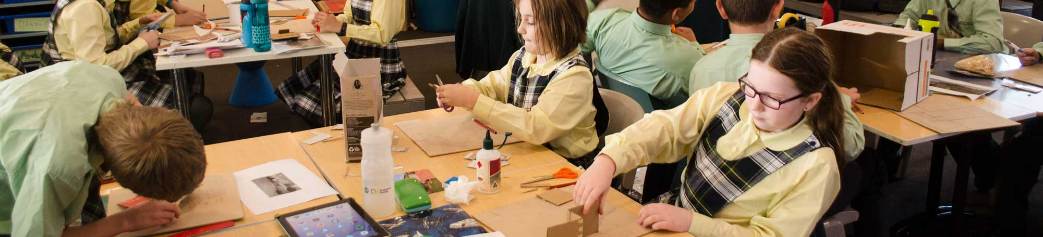

Conditions of Employment
Applicants will be subject to employment screening and must satisfy child protection legislation.

Referees
As part of the selection process, details of three referees will be contacted after discussion with the candidate.

Please include the referees details with your application.

Em Cassin | July 13, 2017



EMPLOYMENT APPLICATION FORM
Teacher: Prep / Primary / Secondary School; Full Time / Part Time Position
Position applied for |  |  | Date
From where did you hear about this position

PERSONAL DETAILS |  |  | (Data used by School Administration for employment purposes only)
Title |  | Surname
Given names
Address
Postcode |  | Email
Telephone | (H) |  |  |  | (W) | (M)

CHRISTIAN BACKGROUND |  |  |  | (Ministerial reference required)
Do you consider yourself a Christian?
Why?
Which church do you attend?
Attendance |  | Weekly Fortnightly Monthly Occasionally
Minister’s name

QUALIFICATIONS |  | (If qualifications are from outside of NSW please include  evidence that you are able to teach in NSW)
Years attended | Educational institution |  | Name of award/qualification | Date conferred

EMPLOYMENT HISTORY IN TEACHING |  |  |  | (Proof of employment may be required)
Start Date | End Date | Employer | Role/ Job Title |  | F/T | P/T | FTE

PREP-PRIMARY TEACHING EXPERIENCE |  |  | (Proof of employment may be required)
Grade | Number of years teaching this grade |  |  | Most recent year  this grade was taught | F/T | P/T | FTE
e.g. Year 4 | 2 years |  |  | 2006 |  |  | 0.8
Prep
Kindy
Year 1
Year 2
Year 3
Year 4
Year 5
Year 6
Specialist Roles (please describe):

Number of Casual Days Taught

SECONDARY TEACHING EXPERIENCE |  |  |  | (Proof of employment may be required)
Subject | Highest year and level taught |  | Number of years taught at this level |  | Most recent year  this level was taught | F/T | P/T | FTE
e.g. English | Year 11 Advanced |  | 2 years |  | 2008 |  |  | 0.6
Number of Casual Days Taught

EXPERIENCE OTHER THAN TEACHING |  |  | (Proof of employment may be required)
Start Date | End Date | Employer |  | Role/ Job Title | F/ T | P/T

REFEREES
Please notify all referees that the school may contact them regarding your application
MINISTERIAL REFEREE | (Required)
Name | Nature of Acquaintance |  | Contact Number/Mobile
CHARACTER REFEREES | (At least one required, in addition to ministerial referee above)
Name | Nature of Acquaintance |  | Contact Number/Mobile
PROFESSIONAL REFEREES | (At least two required, including a recent school principal or supervisor)
Name | Professional Relationship |  | Contact Number/Mobile

NSW INSTITUTE OF TEACHERS
Are you a NSW institute of teachers new scheme teacher? | Yes No
If so, what is your institute number?

SUPPORTING STATEMENTS
Profile any special training, experience or interests that you may have which may strengthen your employment application
Please add any comments or offer clarification to any aspects of your application

CHILD PROTECTION
The Commission for Children and Young People Act 1998 makes it an offence for a prohibited person (a person convicted of a serious sex offence, the murder of a child or a child-related personal violence offence, as well as a Registrable person under the Child Protection (Offenders Registration) Act 2000 to apply for or otherwise attempt to obtain, undertake or remain in child-related employment.
Offers of positions to the successful applicant will be subject to a Working With Children Check clearance number from the NSW Commission and Young People. Please go to www.kids.nsw.gov.au for more information.

ATTACHMENTS AND INCLUSIONS
All staff applications for Mount Annan Christian College must be accompanied by the following attachments:
A recent Curriculum Vitae
Original testamurs and academic transcripts to sight, copy and file on interview or certified photocopies of all qualifications listed
NSWIT Eligibility to teach in NSW letter (New Scheme Teachers)

FORM SUBMISSION | (No application will be considered without completed documentation)
Email completed form, CV and documentation to: employment@macc.nsw.edu.au
or print documents and mail to:
Human Resources
Mount Annan Christian College
PO Box 7039, MOUNT ANNAN NSW 2567

